Brenden Hover

Christopher Gallardo

CSCE 451 : HW4 Writeup

**Flag 1 : Until The Cows Come Home**

This one didn’t start with a specific goal for the flag in mind, but rather a motivation to get the player moving faster and jumping higher for general exploration. To begin, the executable came with one notable dll file, GameLogic.dll, which also had its own pdb file. This allowed us to pop the .dll into a disassembler and get symbol names, so we could get class information, function names, etc. So we put the file into IDA and then began to search for some kind of player class. We found it, and it had the following declarations. 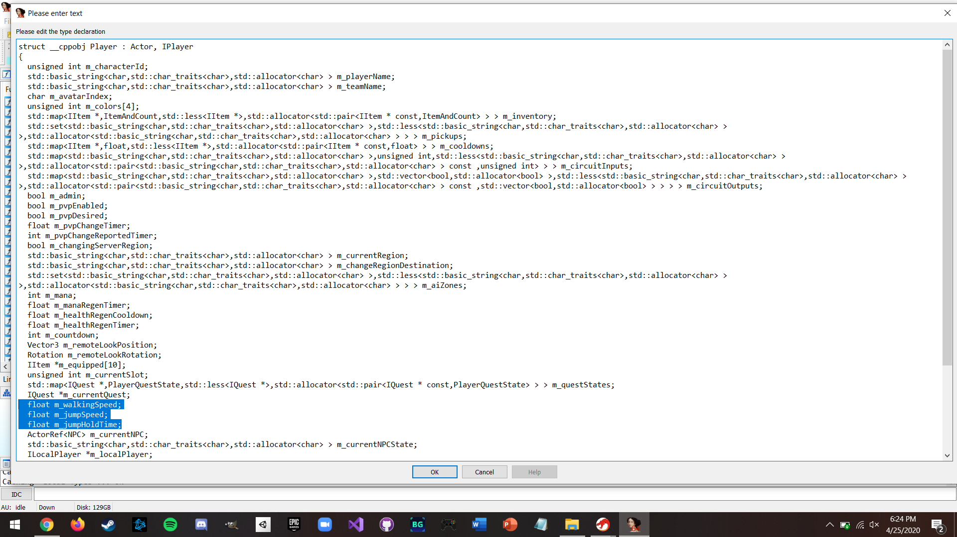

As highlighted, these three values seemed to be exactly what we were looking for. We were planning to use CheatEngine to modify these values in gameplay, but we needed to actually find where they were located in memory first. We essentially needed a reference to the player to latch onto, and then find where that reference was located. Logically, there was probably some World class that contained a reference to the player, and sure enough there was a class called World, which was inherited by ClientWorld, and had the following declarations. 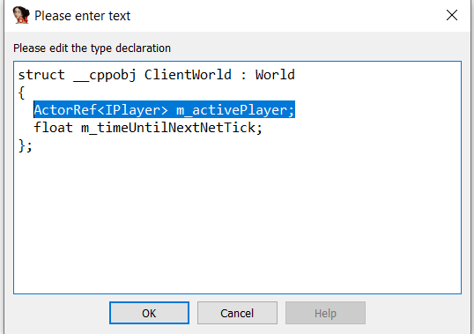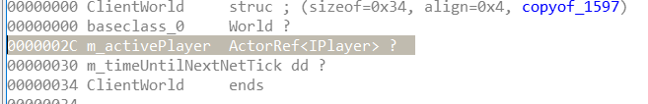

Exactly what we wanted, the current player (us) was stored in here at 2C, but now we needed a reference to this object as well, which was likely some sort of global reference. 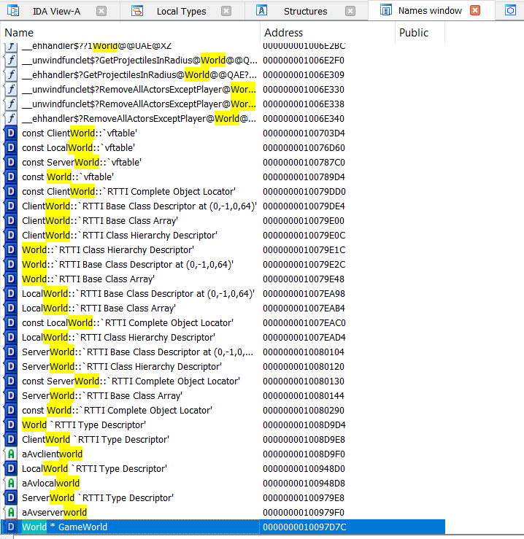 As predicted, we found the instance of the class. We had the address of this world object (10097D7C), and the address of the player within it, and then the offsets of the different values we wanted to change. The next thing we needed was the offset of the world object compared to the base address of the dll. Handily enough, when looking at the base address of the dll itself (didn’t know how to do this in IDA, so we used Ghidra for that), it was 0x1000000, so we could just drop the leading 1 of the address we had to get the offset and bypass the issue of ASLR. Now all we needed was the offset for the player values we wanted to modify, because we had a ref to IPlayer, not Player.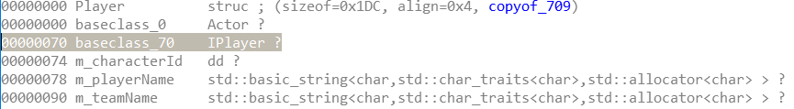When looking up IPlayer, we saw the offset of 70, so we factored that into the values we got from player. 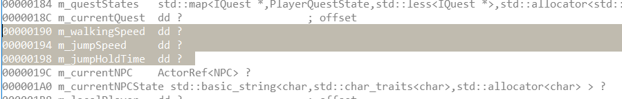 We now had all the values we needed, the address of the world object was at GameLogic.dll + 97D7C (as we calculated the offset bassed off the base address), then we offset that by 2C to get the player, and then offset that by 0x120 (0x190 - 0x70), 0x124, and 0x128 to get the three data members we wanted. We just put these addresses into CheatEngine and were able to modify them. We were now able to jump extremely high and run extremely fast! We jumped very high to see the whole island, and noticed another smaller island far off the coast, so we decided to investigate. Luckily, you can run on the water in this game, so we used our new super speed to get there extremely quick, and found some cows. We had talked to a guy earlier who was missing some cows and had mentioned thunder. One of the cows, who was defending a chest, was shooting lightning at us. We ran into a nearby house and talked to the guy in it. Long story short here (as no reversing for the rest, of this flag), we killed the cow king and completed the quest, with the chest opening and containing the flag for this quest. Without the jump and speed hacks we would have never found the island, much less been able to run to it in a reasonable time. Picture as proof of flag.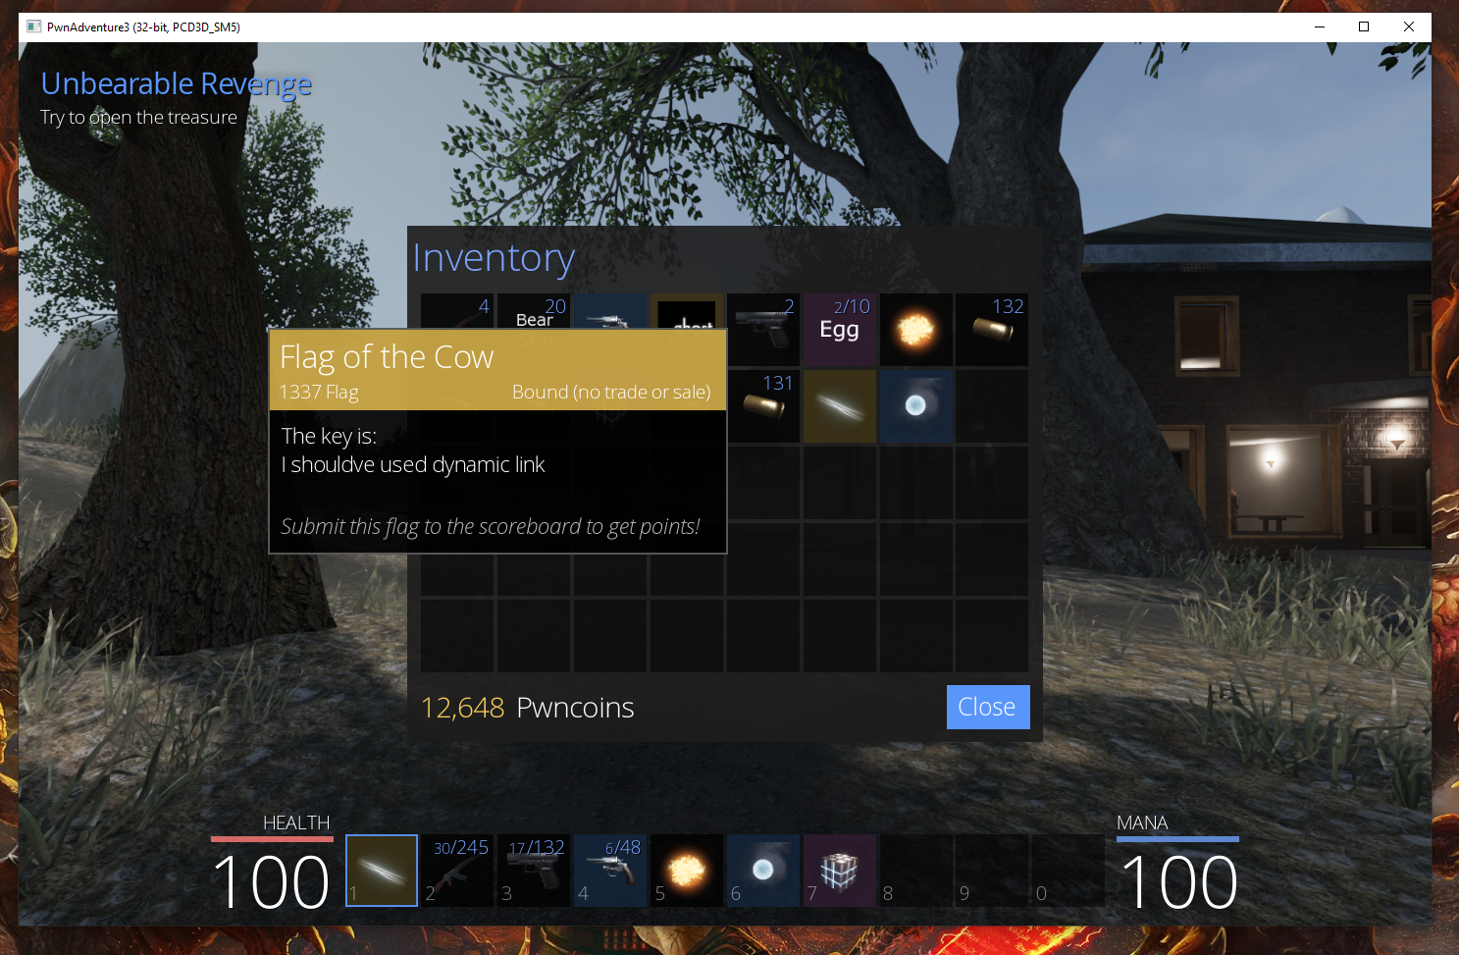

**Flag 2 : Unbearable Revenge**

This flag was a much more targetted approach, and was also performed offline (screenshot of the flag in the inventory below for proof). Basically, we needed to survive 5 minutes with some tough bears to get a flag. The logical solution here was to give ourselves infinite health and infinite mana, so that’s where we began. We did it offline because we were using Windows and getting things to work with the server side of things was quite difficult on Windows. We could have likely accomplished a similar thing to this very easily with CheatEngine just by narrowing down the values for health and mana, but since we were already doing this offline we didn’t feel like that really was sufficient as a “reversing” challenge, so we went about it a more complex and meaningful way. We looked at the dll file in Ghidra this time, but it was a similar process. Thanks to the pdb, we were able to find pretty much all the function names, and began to look around in the player class for some useful functions. 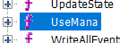

We found this function in particular, which seemed exactly what we were after. If we could reverse this function and then alter the dll to make it perform what we want, then we could bypass mana ever being decreased. There was also a get method for the mana we could use, but this returned a specific value from memory and would be more difficult to handle in this case. So we began by looking into this function, and pulled it up in Ghidra. We got the following output from the disassembler and decompiler (after some renaming of variables), and we determined that the two highlighted lines, particularly the bottom of the two, would be our primary target.

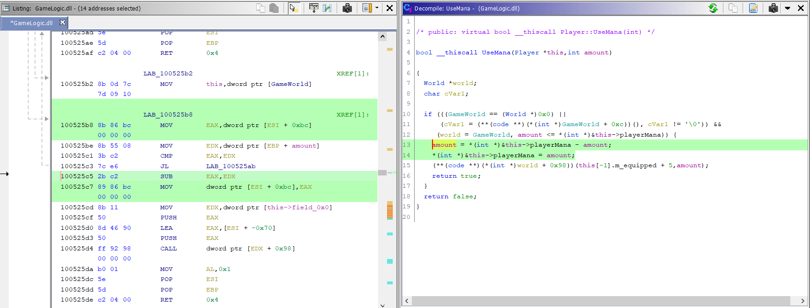

Pretty much all we needed to do was to prevent this line from actually executing, which, in theory, was easy. We just needed to open the dll in a hex editor and change these instructions to NOP instructions (90 90). Only issue was that the values here, 100525c5 and 100525c7, were not going to work in this case. These were virtual addresses, and we needed the real offsets for our purposes. We calculated this by using objdump -dF on the dll file, and searching for some jump instruction, as this would show us where it jumped, and that jump’s offset. That way, we could subtract the two and get the overall offset of the file (which would help a lot later as well).

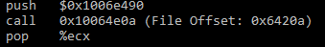

We calculated the offset to be 0x10000c00, so, in order to find what we were looking for, we only needed to subtract this from our given values. We calculated the values and then overwrote these 4 bytes (519C5 - 519C8) with 90 to get our NOPs in place. We then booted up the game with our changed dll file to try it out, and it worked! Perfect, now that we knew how to patch instructions manually offline, we could do a lot of stuff easier. Next step was to get infinite health working. There was no obvious function we could find in the player for damaging, so we thought this must have been some more general function for all players and enemies. We looked for the word “damage” in the symbol tree, and found this function.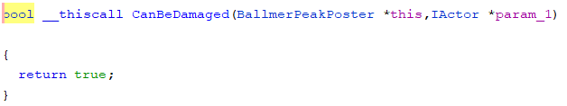

In theory, trying to change this to return false WOULD make us immortal, but it would also do the same for all enemies. Might work for just the bear flag, but there had to be a better way around this. This is when we researched around something called a vftable, as we noticed the player had one of these, which seemed to contain function names that the player itself didn’t have (source <https://en.wikipedia.org/wiki/Virtual_method_table>). With our basic understanding, it seemed to be how dll files handle virtual functions. Essentially, it seemed to be an array pointing to functions from outside the class that this class implemented in some way.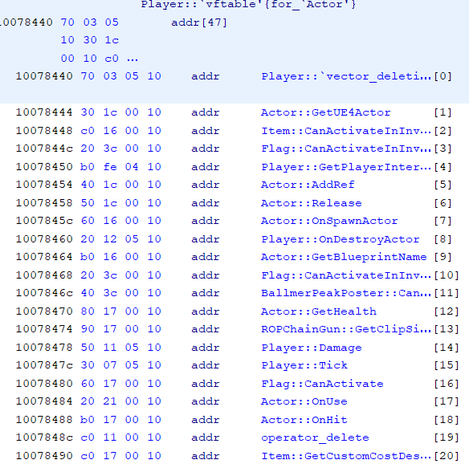

In the vftable, at index 11, we found our function (cut off a bit in the picture, but we double-clicked it to be sure it was the right one). It seemed that, whenever checking if the player could be damaged, the program would call whatever was at player vftable[11]. Since this function just returned true, we would, in theory, be able to just patch the dll to change vftable[11] to redirect to something that returns false always. This would only apply to the player, obviously, and let us no longer receive damage. Quite conveniently, the function at vftable[2] did just this.

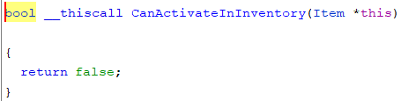

So all we needed to do now was to patch the address for this function into the one for vftable[11] (so replacing the 40 3c with a c0 16). This also involved the offset calculation stuff from earlier, but it was the same idea so we’ll skip the details. Now, we should have infinite health and mana in offline mode, and therefore be able to get the bear flag. Sure enough, everything worked as we intended and we were able to get the flag (the infinite mana wasn’t really needed but it was kinda fun to blast the bears with infinite magic). Image as proof.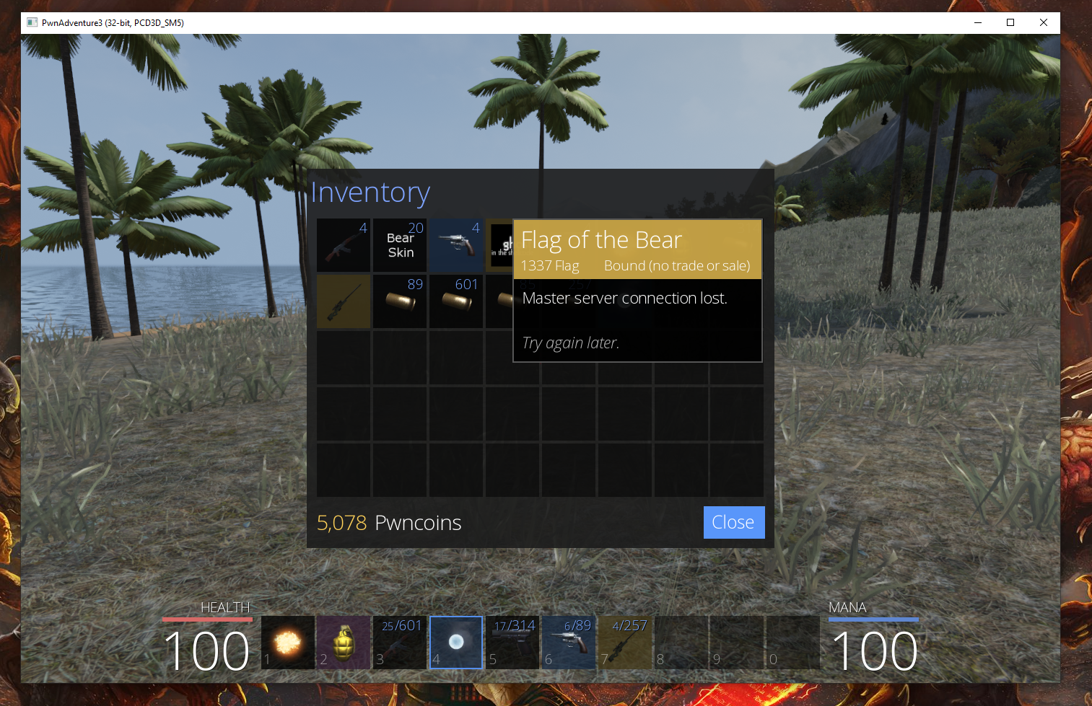

**Flag 3 : Fire and Ice**

Next we decided to tackle Magmarok, the fire demon in the mountains. He seemed like a fairly standard fight, but he would always fully heal himself when at half health, becoming unkillable. Naturally, we thought there was probably some function we could patch to change this. We easily found Magmarok’s functions, but none seemed obvious as to performing the healing. I (Brenden) have experience with Unreal engine, so I suggested we check out the tick function, as this is essentially called every frame. Sure enough, there was a condition in the tick function that checked whether or not his healing was active. It was implemented as a JZ to execute the case when he was not healing.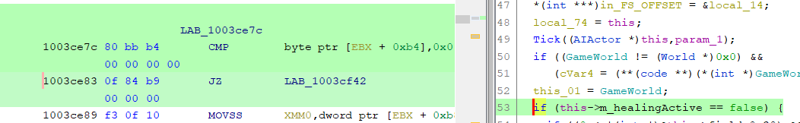 We figured it would be just as easy as changing this JZ to a JMP so that it always would execute the not healing path. We used Ghidra to patch the instruction to a JMP in order to get the correct hexz values to replace 0f 04 b9 00 00 00 with (it ended up being e9 ba 00 00 00 00), and we changed these in the dll like previously. Now, in theory, whenever he would normally heal, he would no longer be able to. Once we went to test, he actually did start his healing animation when at half health, but nothing actually happened with his health and he was able to be killed. Since the animation was played, we clearly missed something with the way the event was called, but our solution defeated the actual health regeneration, which is obviously the important part. The chest opened when he died and we got the flag. Image as proof.

